KWHL Chart
One method that many educators use is to have students create a KWHL chart, which prompts individual students to record what they know about a topic, what they want to learn about that topic, how they plan to learn it, and what they learned at the end of the unit or activity. This is a great way to activate prior knowledge and to have students personalize their learning goals—one of the research-based classroom recommendations.
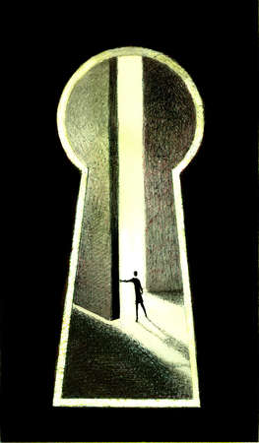
Current Understanding:

K what I already know | W what I want to learn | H how I plan to learn it | L what I learned
Nonlinguistic Representation

